Analog Design
- Id Vs Vds(Please zoom in on the graph as colour is light)
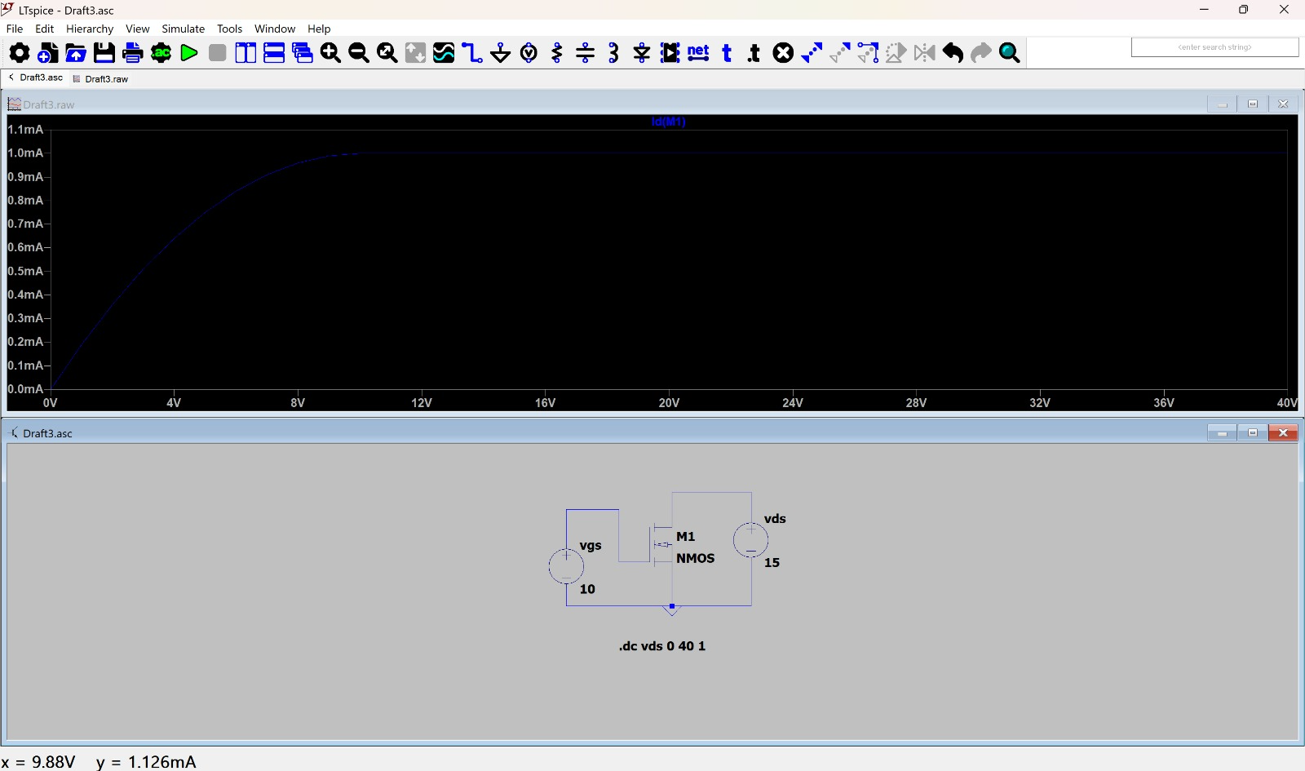
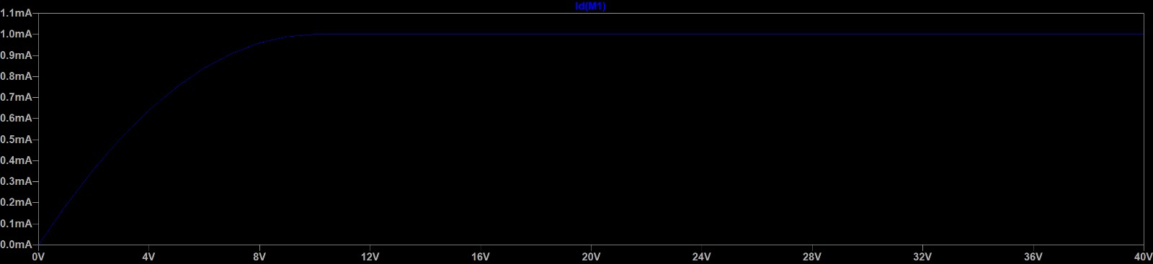
Circuit construction: An Nmos with drain connected to Vds and source connected to ground , gate connected to Vgs.
Inference: From the graph we can see that the mosfet reaches triode region at around 8V after which it enters the saturation region due to pinch off . In pinch off condition the electrons fall into drain when x tends to l .

- Id Vs Vgs
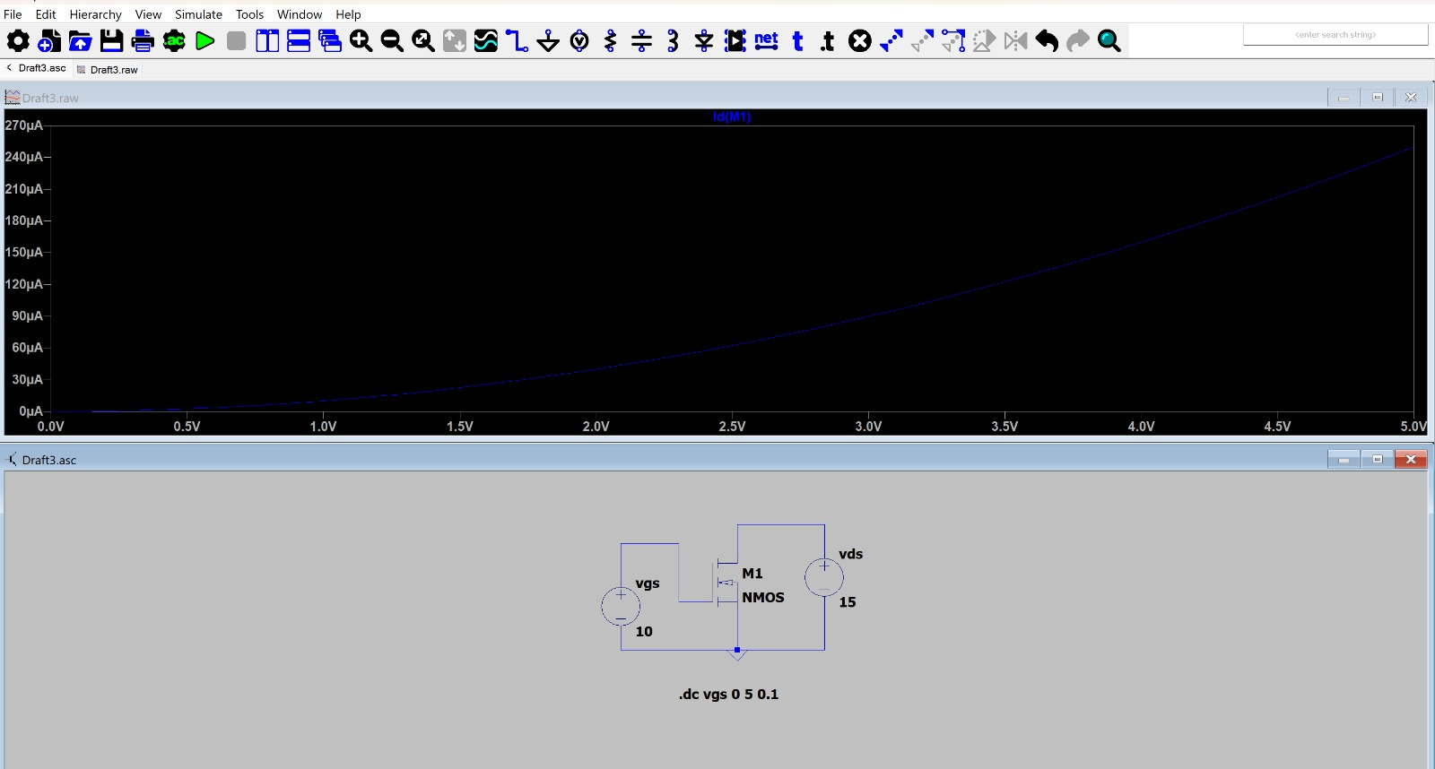
Circuit construction: An Nmos with drain connected to Vds and source connected to ground , gate connected to Vgs.
Inference:The graph shows that current increases with Vgs in a quadratic way as ID​=K(Vgs−Vth​)^2 . Mosfet starts working and Id>0 when Vg>Vth.
3)Second Order Effects
Second Order Effects in mosfets mean they are not behaving ideally according to square law i.e 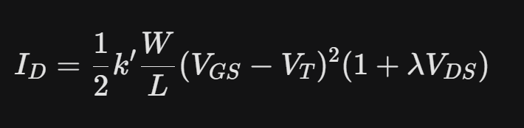 . The following are some of them :
i)Body Effect
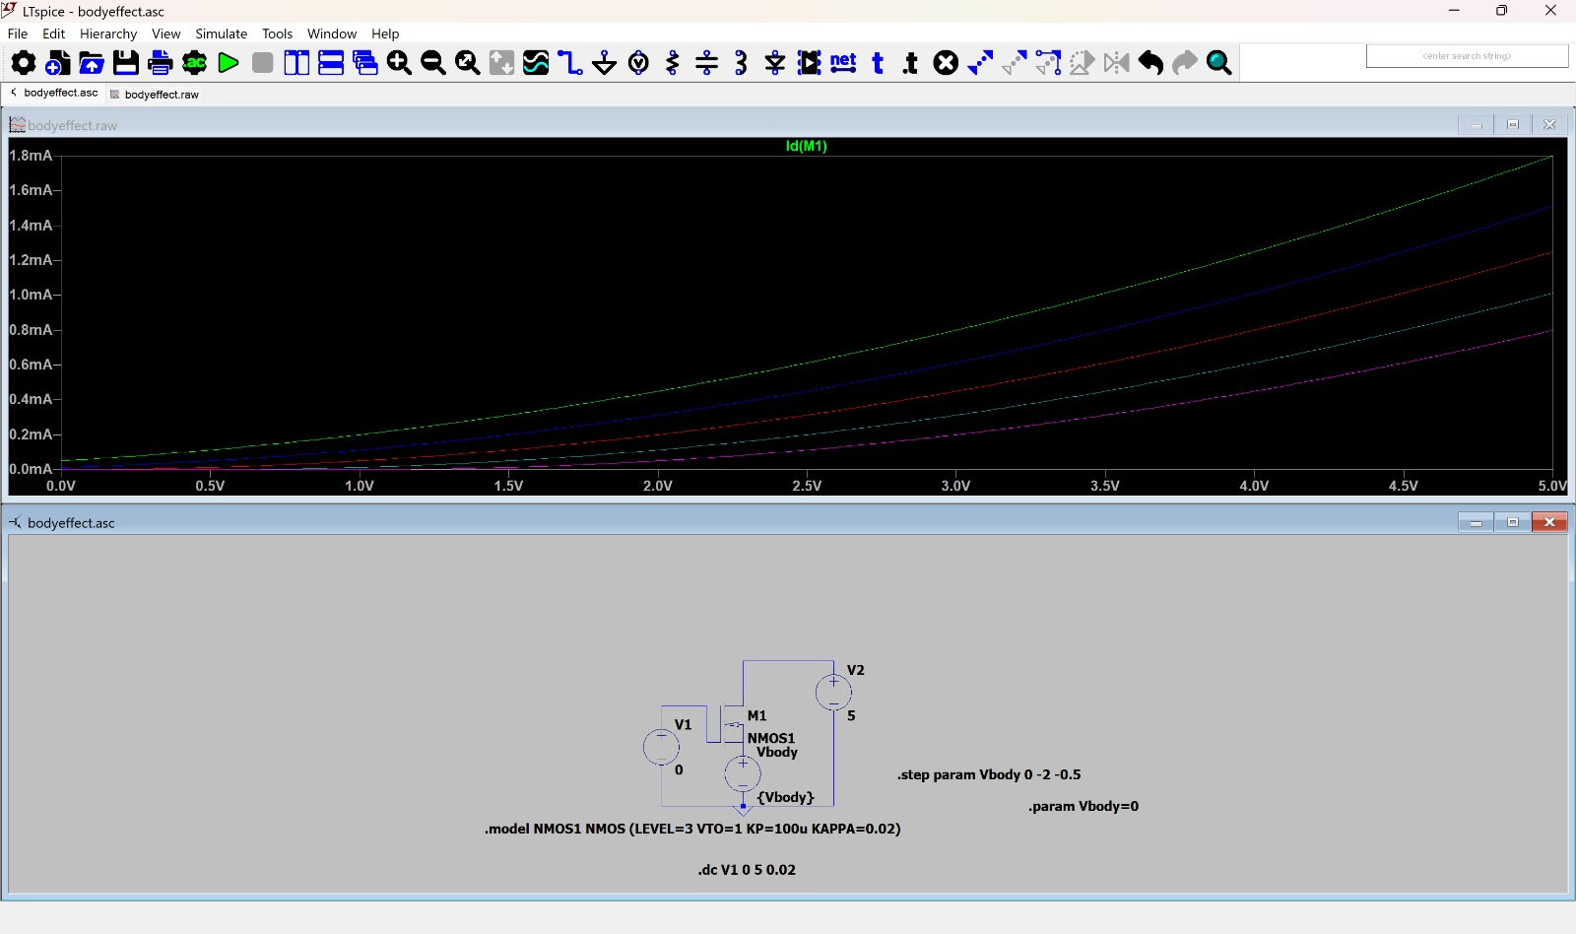
Circuit: Nmos is connected to source that is connected to Vbody, drain is connected to V2, Source is connected to V1=0V.
Inference:The graph is between Id and Vgs.Body effect is basically when the source terminl and body terminal are not at the same potential. When body becomes more negative Vsb increases,reverse bias increases as Vs>Vbresulting in Vth increase. Thus the mosfet needs more gate voltage . Above is a family of curves and each curve has different Vth values, the bottommost will have highest Vth as Vb in tht case will be most negative and vise versa.Thus there is a shift in the curves towards right as Vgs is proportionate to Vth .

ii)Channel Length Modulation
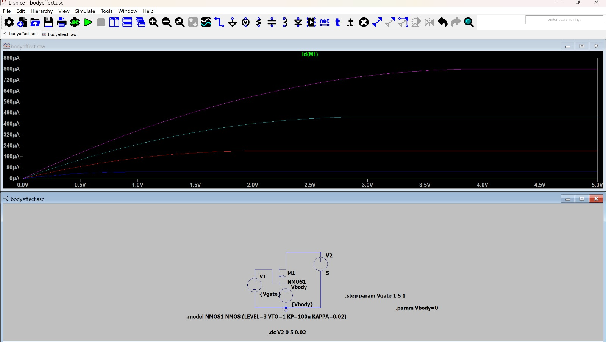
Circuit:Same as body effect but change V1 to Vgate.
Inference:In the saturation region, the Id vs Vds should be flat but in reality as Vds increases the depletion region near drain widens reducing the Leffective and since Id is inversely proportionate to Leff , it increases. Te slight upward slope continues. At Vds = 3.0, follow the line to the Y-axis. The current is sitting around 760 micro amp.Follow that same purple line all the way to the right edge at Vds = 5. Notice that it has crept slightly upward and is now sitting closer to 800 micro amp.

iii) Subthreshold Conduction
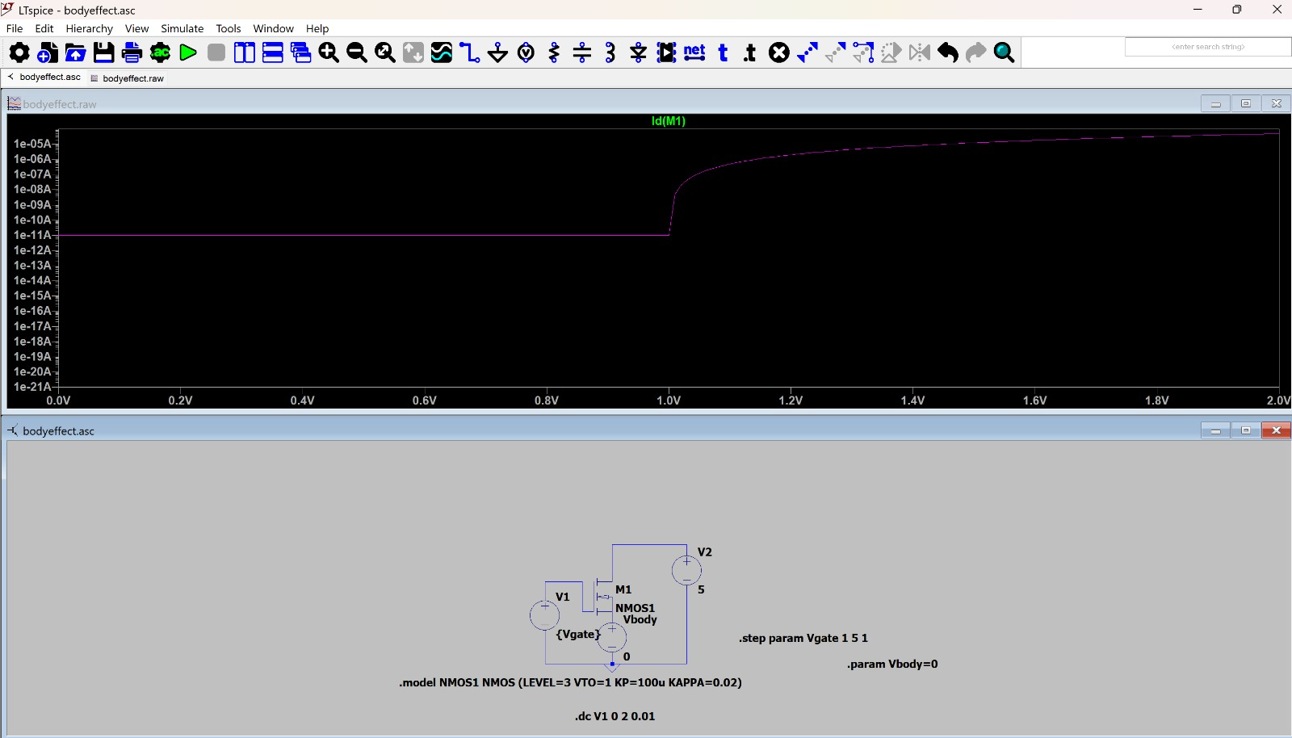

Circuit:Vbody is set to 0.
Inference:Graph is between log( Id )and Vgs.Even if Vg<Vth , a small leakage current flows in the mosfet due to diffusion. This mathematical scaling acts like a microscope, blowing up the tiny, microscopic current values so you can track what happens when the device is supposed to be turned off.The math governing diffusion current is purely exponential with respect to Vgs. Because log(e^x) = x, an exponential current plotted on a log scale reveals itself as a perfectly straight line up until it hits Vth. 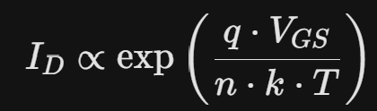

iv) Drain-Induced Barrier Lowering

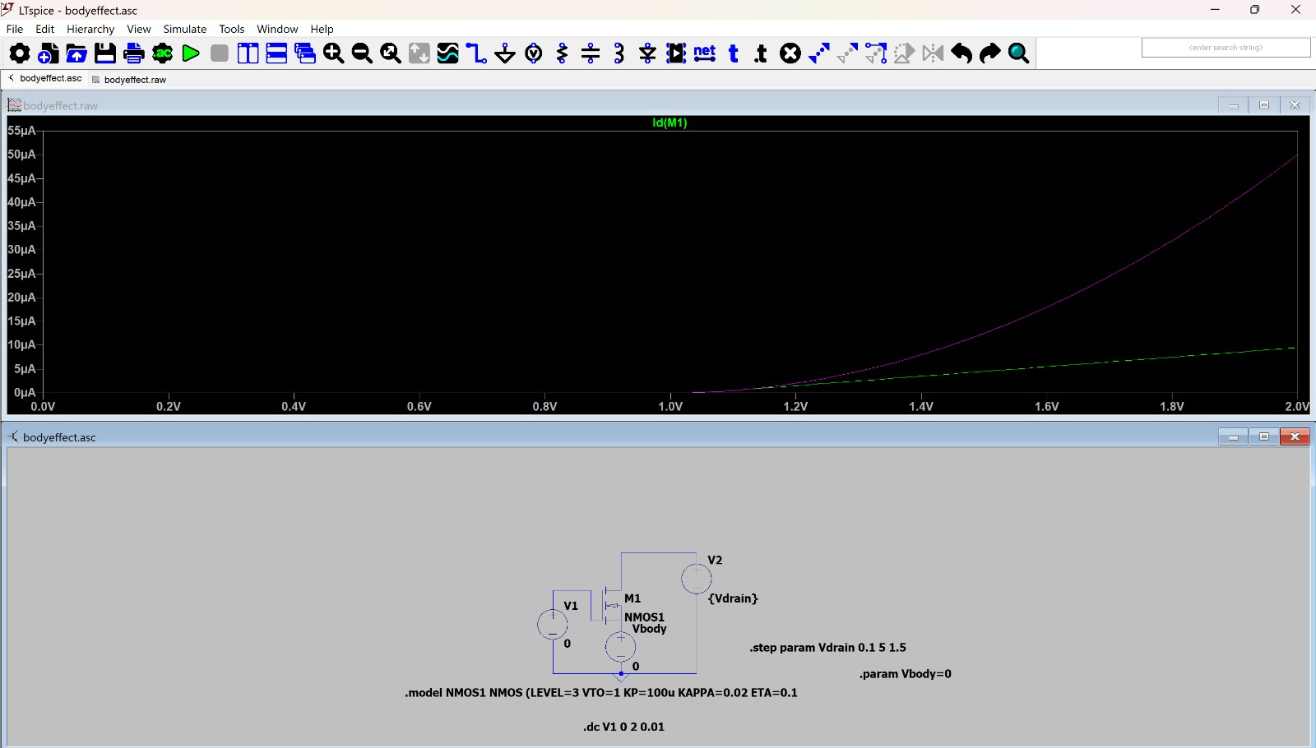
Circuit:V1=0;Vbody=0.
Inference: In a short-channel transistor, the depletion region around the drain is quite large. As you increase , this depletion region extends further toward the source.This physically lowers the potential barrier that electrons have to "climb" to get into the channel.Because the barrier is lower, the gate doesn't have to work as hard to start the current flow, which is why the "turn-on" point moves to the left. The Purple Curve (Vdrain = 5: It lifts off the 0 micro amp baseline first, right around 1.01. The Green Curve (Vdrain = 0.1): It stays flat at 0 micro amp longer and doesn't start lifting off until about 1.06.
Because 1.01 is to the left of 1.06, the transistor with the higher drain voltage turns on sooner. That is a leftward shift in threshold voltage (Vth).

v) Mobility Degradation
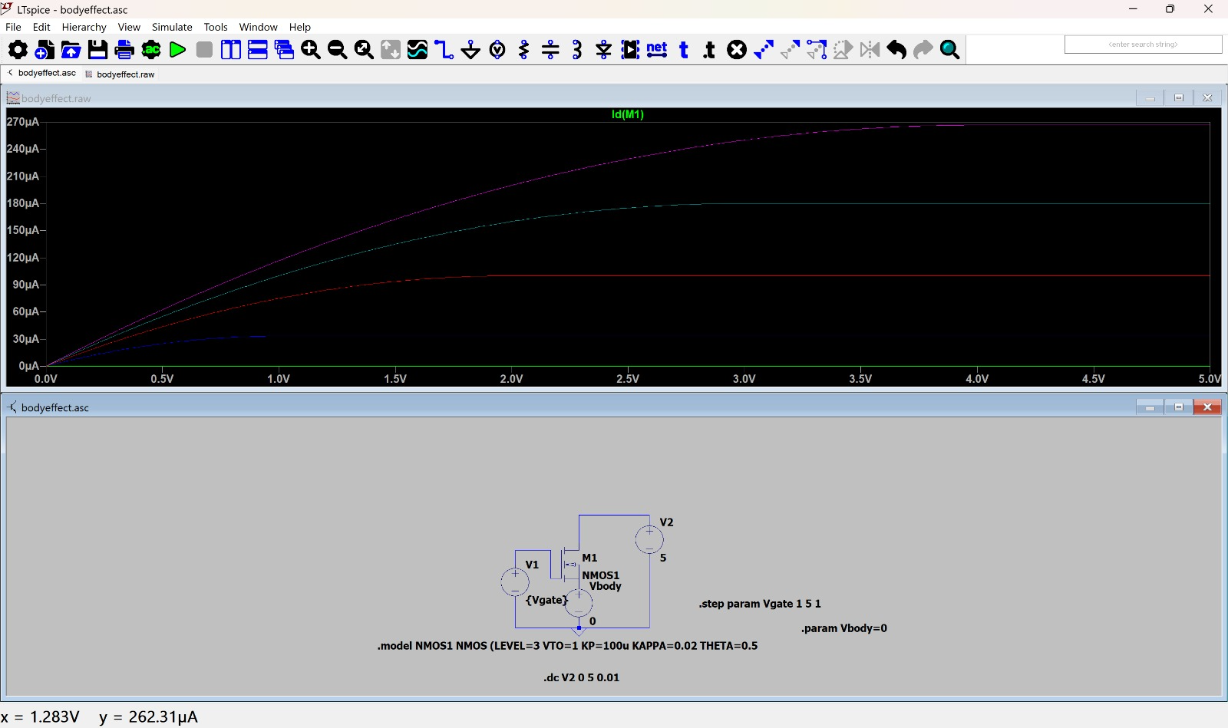
Inference:(Id vs Vgs) In the basic MOSFET model, we assume mobility is a constant. However, as you increase the Gate-Source voltage , the vertical electric field pulls the electrons harder toward the Silicon-Oxide interface. The electrons start "bumping" into the surface more frequently, and the Id curve starts to "flatten out" or become more linear rather than quadratic.Thus around 5v they flatten out as seen above. Even though you are giving the transistor more voltage input, the electrons are too slowed down by the ceiling bumps to move any faster. As a result, the top curves on your graph choke, get squeezed closer together, and flatten out rather than leaping higher.

vi) Temperature Dependency(Id Vs Vds)
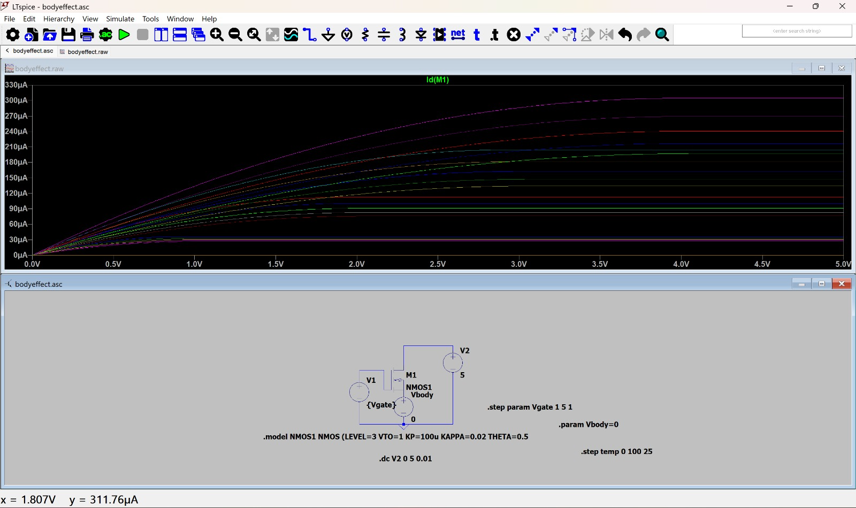
Inference:In reality , modfets don’t stay cool at 27 deg celcius, they heat up as they run and this effects the mobility and threshold voltage. Vth Shift: As temperature rises, the threshold voltage actually decreases. As temperature rises, the silicon lattice vibrates more, causing more collisions for the electrons. This decreases mobility, making the transistor "slower" and reducing the total current. 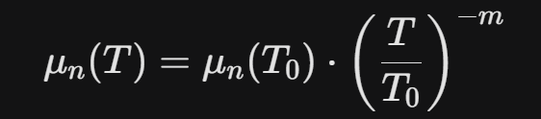 At high gate voltages (like Vgs = 5), this effect dominates. As temperature increases, the drain current Id drops. Therefore, within that top cluster of curves, the highest curve represents 0 deg and the lowest curve represents 100deg.

